Draft Minutes of RCN 10/3/14

Opened at 7:17 pm at Embassy Suites, Portland

Attending were Mark Yackel Juleen, Alvin Luedke, Judy Hill, Brian Arnold, and Dave Ruesink.

Meeting opened with devotion by Alvin from 2nd letter of Corinthians regarding ministry of reconciliation.

Checking in:

Alvin
Luther Seminary is coming back on feet after two years of financial difficulty. June 1 new President and October 1 a new CFO. New curriculum this academic year. Very hopeful new spirit under new President. Alvin was interim division chair until June 30.

Judy
Everything is fine except building a new house is stalled right now.

Bryan
After two long-term pastorates, In parish now in first year in new church. A place with some “birthpains” following pastor of 13 years.

Mark
Will transition out of present work in 2015. Tuesday was 25th anniversary of ordination. SW Minn for all of call. Dean of local conference then Chair of Council of ten Councils in 2012 and re-elected in 2014 for two years. SHF and parish is healthy so can hand over baton to Rachel Redmond. In June, there will be a new Bishop.

Minutes from last meeting had been sent out and no corrections were received. Judy and Alvin moved acceptance.

Treasurer’s report
This is the electronic report submitted by Lon:
The checking account balance as of 9-23-2014 is $1,288.37.

Still needing Secretary of State papers of incorporation from ND in order to open new checking account in College Station.

RSSE
Lon, David, Gary Farley and Mark met in Birmingham earlier to review previous RSSE material. Rather than a Rural Church and Rural Community reader, the intent is to weave both curriculums into one study and put on line for uses. Cornelia Flora has indicated a willingness to be on a conference call about how to be cooperator with RSSE.

It is understood that Lexington Theological is still interested in being involved.

Lon has funding for another meeting in Birmingham with Gary being host at Carrolton, AL. This will take place when more of the material is ready to be brought together.

“Unbinding” is a consultation of folks that Brian was associated with through Lilley funds. Used coaches. Alvin knows someone at Luther who is part of that and will follow up with more contact there.

Brian might be willing to be an advisor with RSSE later on.

Website
See if a counter could be added for hits.

Keep looking for new resources.

New pictures are still desired for categories on the website.

Transitions
Mark has been offered position at Wartburg Theology and the Land. Will teach an on-line class in 2015. Wartburg, Luther, and Gettysburg are the three seminaries that teach rural course for ELCA.

Position for Contextual Teaching at Luther has opened and Mark submitted an application.

Although Lon was not present, he sent this information: I will complete my work with the Christian Church In Kentucky next week. I have already started my ministry at Nicholasville Christian Church. I will be continuing at AMERC.

Fund raising
Dave is to send invoices to judicatories this fall.

IRCA
The International Rural Church Association honored Harold McSwain by presenting a certificate to a young Malayan minister who is making a difference in rural work.

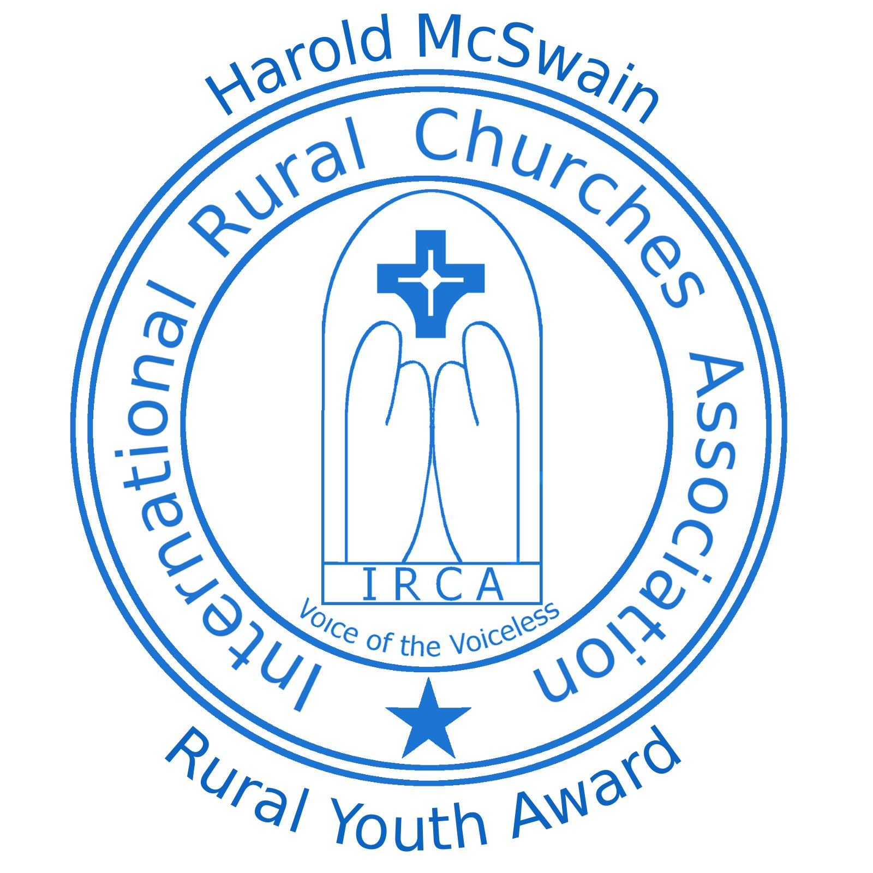
The Harold McSwain
Rural Youth Award
presented to

Mabuchi Mwafulirwa

At the International Rural Churches Association’s 5th Quadrennial Conference in Lilongwe, Malawi, July 28 – August 3, 2014;
recognizing and affirming his dedication and commitment to
Rural Ministry, which was dear to the heart of

Reverend Harold McSwain,

charter member of the International Rural Churches Association.

Reverend Catherine Christie - IRCA Chair Reverend Copeland Nkhata – Local Arrangements

Copeland has requested money for two community water wells at a cost of about $6,000 each. It was suggested that because he is a Methodist minister, he should request funds through UMCOR. We should keep him in prayer and help him work through the Methodist denominational structure and other NGO’s.

Executive Secretary.
Since last fall’s meeting, efforts have concentrated on:
- Making phone contacts with primary funders with email follow up as recommended afterwards.
- When contributions are received, they are recorded and mailed to the Treasurer.
- Minimal supervision has been provided for the webmaster.
- Emails and other sites are monitored for information that might be useful to forward to the RCN listserv.
- RSSE material is being reviewed and ready to rework for the revised version.

UMRA
Watching legislative session working was revealing. Ecumenical Ministry of Oregon hospitality at the Beaver Creek UCC church was worthwhile. It was inspiring to see intentional rural presence with a good staff promoting the work. Might encourage other seminaries to have students attending national conferences to see how the system works. Joint meeting at the UMRA consultation was worthwhile.

Michele Holloway provided transportation along with two vehicles from the EMO. Dave was authorized to purchase a $20 gift card to send to her and send the bill to Lon to be paid as one way to tell her thanks.

Thanks to others:

- David Leslie
- Women at the Church

Next conference call April 16 at 10:00 central

Adjourned with the Lords Prayer at 9:35.

